Module 5: Intelligent Agents
Individual e-Portfolio Submission

University of Essex Online

Student ID: 36932

Final Module Assignment – Unit 12

e-Portfolio URL: https://ie25073.github.io/

Portfolio Narrative

Learning journey and evidence
This portfolio records my progression from analysing autonomous agents to designing, implementing and evaluating an academic research agent. In Units 1 – 3, the first collaborative discussion established that autonomy is not an isolated technical property. My initial emphasis on delegation developed through peer exchanges into a risk-based view: routine, reversible actions may be delegated, but consequential decisions require monitoring, approval and override. The summary connects autonomy with reactivity, proactivity, social ability and the possibility of emergent behaviour (Wooldridge and Jennings, 1995; Jennings, 2000). It provides evidence for learning outcomes 1 and 4 because it compares agent properties while showing how discussion changed my position on organisational responsibility.
Units 5 – 7 moved from agent architecture to communication. My forum work compared KQML with conventional method invocation. KQML can express communicative intent while preserving internal autonomy, whereas a Python or Java call is simpler and faster inside a stable component. The Alice and Bob exercise converted theory into executable Python: KQML performatives represent the dialogue act, KIF represents warehouse facts, and conversation and reply identifiers preserve context. Tests cover valid replies and an unknown-stock failure. The exercise also exposed a limitation: syntactically valid messages do not guarantee shared meaning. My summary therefore argues for ontology versioning, bounded conversations and recoverable failures rather than treating an agent communication language as sufficient for interoperability.
The Unit 8 constituency exercise strengthened my understanding of representation. Two parse trees for “The man saw the dog with the telescope” encode different prepositional-phrase attachments. An agent selecting one interpretation from syntax alone may act on the wrong meaning; semantic and contextual evidence is required. This small task connects directly to the final project, where a plausible title or abstract is not automatically relevant evidence.
Units 9 – 11 focused on deep learning, ethics and deployment. My discussion traced risks including confabulation, bias, privacy, intellectual property and over-reliance. Peer responses broadened my initial output-focused view into a lifecycle perspective involving representative evaluation, provenance, human review and continuing monitoring (National Institute of Standards and Technology (NIST), 2024). The additional activity applied this directly to fabricated academic citations, defining publication-identity and claim-support checks rather than relying on fluent output.

Evidence of collaboration and individual contribution
My Group C contribution focused on development methodology and the selection of frameworks, APIs and models. I initially proposed Agile prototyping, SQLite and named development tools. Team discussion challenged whether those choices belonged in the architecture and whether they were proportionate to a lightweight academic prototype. I revised my contribution to an architecture-first design, supported replacing SQLite with JSON, removed tooling from the architectural requirements and helped make the LLM layer provider-agnostic. This shows individual contribution through revision rather than ownership of a fixed idea. The supporting team-discussion reflection, peer-evaluation record and methodology/tools contribution in the e-portfolio provide an auditable record of participation. The experience also exposed a weakness in my original approach: I had treated familiar technologies as if they were requirements. The collaborative review forced me to separate the problem, architectural responsibilities and implementation choices, which made later individual implementation more disciplined and easier to test (see Appendix B).

From Week 7 Design to Week 11 Implementation
The Week 7 design proposed four specialist responsibilities; planning, retrieval, processing and storage with LangGraph, Pydantic, HTTPX, Tenacity and multiple scholarly APIs as implementation options (Group C, 2026). By Week 11, the implemented artefact preserved those boundaries but deliberately reduced dependencies: typed Python components replaced framework-specific orchestration, OpenAlex became the implemented live provider, and JSON/Markdown remained the persistence formats. Optional Ollama planning was constrained by schema validation and deterministic fallback. The final workflow also added measurable controls: a test run reporting 11 passing tests and eight passing subtests, a three-cycle limit, execution traces, a four-query synthetic ranking evaluation and a planner-resilience benchmark.
This was not a simple implementation of every Week 7 technology. Removing LangGraph, Pydantic, HTTPX and Tenacity reduced installation complexity and made the assessed behaviour easier to reproduce, but it also meant losing richer orchestration, asynchronous networking and built-in retry mechanisms that would matter in a production system. Similarly, implementing only OpenAlex reduced source breadth compared with the proposed arXiv/OpenAlex/CORE design. I therefore regard the Week 11 solution as architecturally faithful but technologically narrower. This comparison changed my view of architectural fidelity: preserving responsibilities, interfaces and evaluable behaviour mattered more than reproducing every proposed tool.
The Unit 11 implementation therefore demonstrates bounded workflow autonomy rather than unrestricted independent agents. A planning component converts a goal into two to five validated search tasks; retrieval queries OpenAlex or an offline fixture; processing normalises, deduplicates and ranks evidence; and storage writes Markdown, JSON and an execution trace. If evidence is insufficient, later cycles refine the existing searches and repeat retrieval within a maximum of three cycles. The reproducible demonstration retained three evidence records and generated the expected outputs. These results demonstrate software behaviour and resilience, not the scholarly quality of a real literature review (see Appendix C).

Learning outcomes
- Architectures and approaches: forum analysis, the KQML/KIF exercise and the four-role project distinguish reactive communication, deliberative planning and cooperative agent responsibilities.
- Application under uncertainty: the final system applies planning and retrieval to academic research while exposing incomplete metadata, shallow relevance scoring and model/network failure.
- Tools and responsibility: Python, unit testing, OpenAlex, Ollama, provenance records and bounded execution demonstrate deployment choices informed by ethical and professional risk.
- Virtual teamwork: discussion posts, peer responses and the Group C design record evidence review, negotiation and revision of my own proposals.

Formative case studies

Case study 1: Bias in autonomous ranking
What? The processing agent ranks retrieved works using keyword overlap and a bounded citation-count signal. This is transparent and repeatable, but citation counts can favour older, highly visible or well-resourced research communities.
So what? A deterministic score is not neutral merely because it is explainable. Ranking affects which evidence a researcher sees first and can reproduce structural inequalities in scholarly visibility. OpenAlex coverage and missing abstracts can introduce source-selection bias. This challenged my earlier tendency to equate reproducibility with fairness.
Now what? I would create a manually labelled evaluation set spanning publication years, disciplines and regions, report ranking performance by subgroup, and let users switch or remove citation weighting. The interface should explain the score and show unranked or low-ranked results rather than hiding them.

Case study 2: Safety constraints and bounded autonomy
What? The workflow plans an initial set of search tasks, retrieves evidence, assesses sufficiency and can perform further bounded retrieval cycles. I implemented two boundaries: two to five validated planning tasks and a maximum of three cycles. An unavailable or malformed LLM response triggers a deterministic fallback. These explicit state and stopping rules constrain autonomous behaviour (Russell and Norvig, 2021).
So what? Unit 1 discussions had framed overrides abstractly; implementation made the issue operational. A loop without a stop condition can waste resources, amplify weak queries or repeatedly contact an external service. Safe failure is therefore part of correct behaviour, not an optional restriction. The test that forces insufficient evidence and confirms the cycle limit provides direct evidence.
Now what? A deployed version should add time and request budgets, cancellation, rate-limit handling and alerts. Higher-risk actions should require explicit human approval, with the trace preserving who approved what and why.

Case study 3: Explainable decisions and evidence provenance
What? The agent preserves source URLs, DOI metadata, matched queries and retrieved abstract text. Its trace records planning, searches, failures, counts and stopping decisions. Reports explicitly state that retrieved summaries are not model-generated conclusions.
So what? Walters and Wilder (2023) show that language models can fabricate citations. In a multi-agent system, unsupported content can pass between roles and acquire credibility through repetition. Exposing process steps helps, but a trace only explains what the software did; it does not prove that a source is credible or supports a claim.
Now what? I would add DOI-resolution checks and sentence-level links between claims and source passages. A manually assessed claim-support benchmark and a measure of appropriate abstention would test whether explanation corresponds to evidence. Human verification would remain mandatory before academic use.

Professional skills matrix and action plan
Skill | Evidence developed | Current evaluation | Action
Critical analysis | Three discussion summaries and design critique. | Stronger at comparing trade-offs than at the module start. | Quantify comparisons with explicit evaluation criteria.
Software engineering | Modular Python, typed models, CLI and eight tests. | Reproducible core with clear boundaries. | Add integration tests for live API failure modes.
Research | Reading summaries, scholarly APIs and referenced discussions. | Improved provenance awareness. | Build a manually labelled relevance dataset.
Teamwork | Peer responses and revision of Group C contribution. | Demonstrated responsiveness to criticism. | Record decisions and ownership during future meetings.
Ethical awareness | Risk discussion, three case studies and safety controls. | Able to translate principles into controls. | Add bias, privacy and prompt-injection checks before deployment.
Communication | KQML exercise, reports, README and presentation. | Technical ideas expressed for different audiences. | Practise shorter evidence-led demonstrations.

Final Reflective Commentary
This reflection uses Rolfe, Freshwater and Jasper’s (2001) What?–So what?–Now what? framework to evaluate my development across the module.

What?
My central project was an Academic Research Agent that receives a research goal, plans searches, retrieves scholarly metadata, processes the results and stores an inspectable report. The implemented workflow separates planning, retrieval, processing and storage. It supports optional Ollama planning and OpenAlex for live retrieval, while deterministic fallback and an offline fixture make execution reproducible when a model or network service is unavailable. The final run reported 11 tests and eight subtests passing; the demonstration generated Markdown, JSON and workflow-trace outputs.
Early discussion led me to see autonomy as bounded delegation rather than unrestricted independent action. The KQML/KIF exercise demonstrated that communication has layers: a performative can state intent, formal content can encode a proposition, and identifiers can preserve conversational context. The constituency trees then showed that a valid representation may still permit competing interpretations. Later work on deep learning and responsible AI connected these technical uncertainties with provenance, bias, privacy, oversight and accountability.
My individual Group C contribution focused on development methodology and technology selection. I began with Agile prototyping and suggestions including SQLite and named development tools. Peer discussion challenged whether these decisions belonged in the architecture and whether they were proportionate to a lightweight prototype. I changed the proposal to an architecture-first method, accepted JSON storage and removed avoidable provider and tooling dependencies. That change became important during implementation because explicit component interfaces made the final system testable without requiring every external service.

So what?
At the start, I was most comfortable evaluating an agent by what it could do. The discussions and implementation shifted my attention to the conditions under which its output should be trusted. I found the move away from familiar tools uncomfortable because my initial choices felt concrete and practical. However, defending a preferred stack would have confused implementation convenience with system requirements. The team’s criticism helped me treat revision as evidence of engineering judgement rather than as failure of the first idea.
This changed how I understand autonomy. Wooldridge and Jennings (1995) identify autonomy, reactivity, proactivity and social ability as central agent characteristics, but those properties do not establish that behaviour is safe or useful. In the final system, autonomous task creation creates risk as well as efficiency. A poor initial plan can lead to repeated weak retrieval, and an LLM can return malformed or unsupported content. I therefore constrained the planner schema, limited task and cycle counts, and preserved deterministic fallback. The three-cycle test matters because it turns the abstract idea of a safety boundary into observable behaviour.
Communication work produced a related insight. KQML can communicate intention, but shared syntax does not ensure shared semantics. Likewise, a pipeline can successfully pass a record between components even when that record is irrelevant or misleading. The Unit 8 ambiguous parse reinforced this distinction between valid structure and justified meaning. In the research agent, typed records support structural consistency, while provenance and human review address meaning and evidence quality. Neither substitutes for the other.
My view of explainability also became more critical. Recording a trace improves accountability because it exposes queries, failures and stop decisions. Yet a transparent keyword score can still be biased, and a DOI can identify a real paper without proving that it supports a generated claim. Walters and Wilder’s (2023) findings on fabricated citations made this risk concrete, while NIST’s (2024) lifecycle approach showed why one test result cannot guarantee responsible deployment. I learned to distinguish software correctness, information quality and fitness for use. The offline tests establish the first; they do not establish the other two.
The strongest evidence of my technical development is the path from a design contribution to executable, tested components. I can now define agent boundaries, use replaceable dependencies, validate model output, design deterministic fallbacks and capture execution evidence. My weakest area remains empirical evaluation. The current ranking uses transparent proxies rather than a labelled real-world relevance dataset, and I did not conduct a user study. Acknowledging these limits is more useful than overstating the prototype as a complete systematic-review tool.
Final verification revealed another important lesson. An earlier stored test record did not match clean test discovery, so I reconciled the suite and evidence until the final run reported 11 tests and eight subtests passing. I also corrected the retrieval-evaluation outputs so synthetic fixture identifiers were no longer presented as resolvable scholarly DOI links. These checks showed that documentation can drift from executable reality. I now regard a fresh, repeatable validation run as part of the deliverable rather than a final administrative check.
Team participation also altered my working practice. My peer responses across the discussions introduced coordination risk, ontology alignment, representative testing, privacy and provenance into my conclusions. In Group C, simplifying storage and decoupling providers resulted from collaborative review. I learned that effective virtual teamwork requires visible reasoning and willingness to update decisions. In future, I would maintain a decision log recording options, evidence, owners and acceptance criteria so contribution and accountability are easier to evaluate.

Now what?
My next technical step is to build a manually labelled collection of research goals and candidate papers. I would measure retrieval precision and recall, citation validity, claim support and appropriate abstention, then examine results across disciplines and publication years. I would add DOI resolution, sentence-level evidence links, request and time budgets, cancellation and tests for prompt injection or hostile metadata. Any model or data-provider change would trigger renewed evaluation rather than inheriting trust from the previous configuration.
Professionally, I will begin future intelligent-agent projects with three questions: what behaviour is required, what evidence demonstrates it, and what boundary limits harm when assumptions fail? I will separate architectural requirements from preferred tools, make uncertainty visible and preserve human approval for consequential actions. The module has therefore changed my conception of a successful agent from one that completes a task to one whose actions, limitations and responsibilities can be examined and governed.

References
Group C (2026) Design Proposal for an Academic and Information Gathering Multi-Agent Artificial Intelligence Tool. Unpublished group design proposal. University of Essex Online.
Jennings, N.R. (2000) ‘On agent-based software engineering’, Artificial Intelligence, 117(2), pp. 277–296. Available at: https://doi.org/10.1016/S0004-3702(99)00107-1 (Accessed: 17 October 2026).
National Institute of Standards and Technology (NIST) (2024) Artificial Intelligence Risk Management Framework: Generative Artificial Intelligence Profile. NIST AI 600-1. Gaithersburg, MD: National Institute of Standards and Technology. Available at: https://doi.org/10.6028/NIST.AI.600-1 (Accessed: 29 September 2026).
Rolfe, G., Freshwater, D. and Jasper, M. (2001) Critical reflection in nursing and the helping professions: a user’s guide. Basingstoke: Palgrave Macmillan.
Russell, S.J. and Norvig, P. (2021) Artificial Intelligence: A Modern Approach. 4th edn. Harlow: Pearson Education.
Walters, W.H. and Wilder, E.I. (2023) ‘Fabrication and errors in the bibliographic citations generated by ChatGPT’, Scientific Reports, 13, article 14045. Available at: https://doi.org/10.1038/s41598-023-41032-5 (Accessed: 29 September 2026).
Wooldridge, M.J. and Jennings, N.R. (1995) ‘Intelligent agents: theory and practice’, The Knowledge Engineering Review, 10(2), pp. 115–152. Available at: https://doi.org/10.1017/S0269888900008122 (Accessed: 17 October 2026).

Appendix A – Evidence Index
- Units 1 – 3 – Collaborative Discussion 1 Evidence
- Unit 6 KQML/KIF agent dialogue
- Units 5 – 9 Collaborative Discussion 2
- Unit 8 – Constituency parse trees and ambiguity analysis
- Units 9 -11 – Collaborative Discussion 3/formative activity Evidence
- Group C project – design, peer evaluation, discussion/reflection and individual contribution
- Unit 11 – Academic Research Agent source, tests, README and execution evidence
- E-Portfolio home: https://ie25073.github.io/

Appendix B – Group C Collaboration Evidence
The screenshots below provide supporting evidence of my participation in Group C discussions, decision-making, review and revision activities.
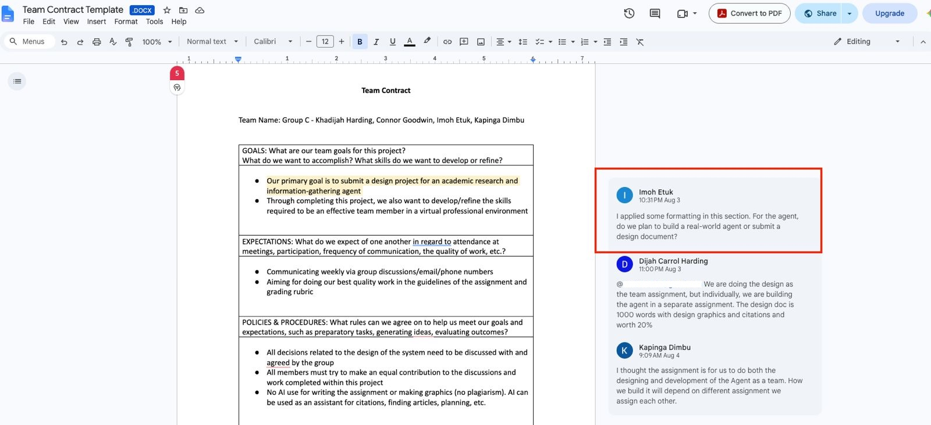
Figure B1. Team-contract discussion showing my question on the scope of the agent deliverable.
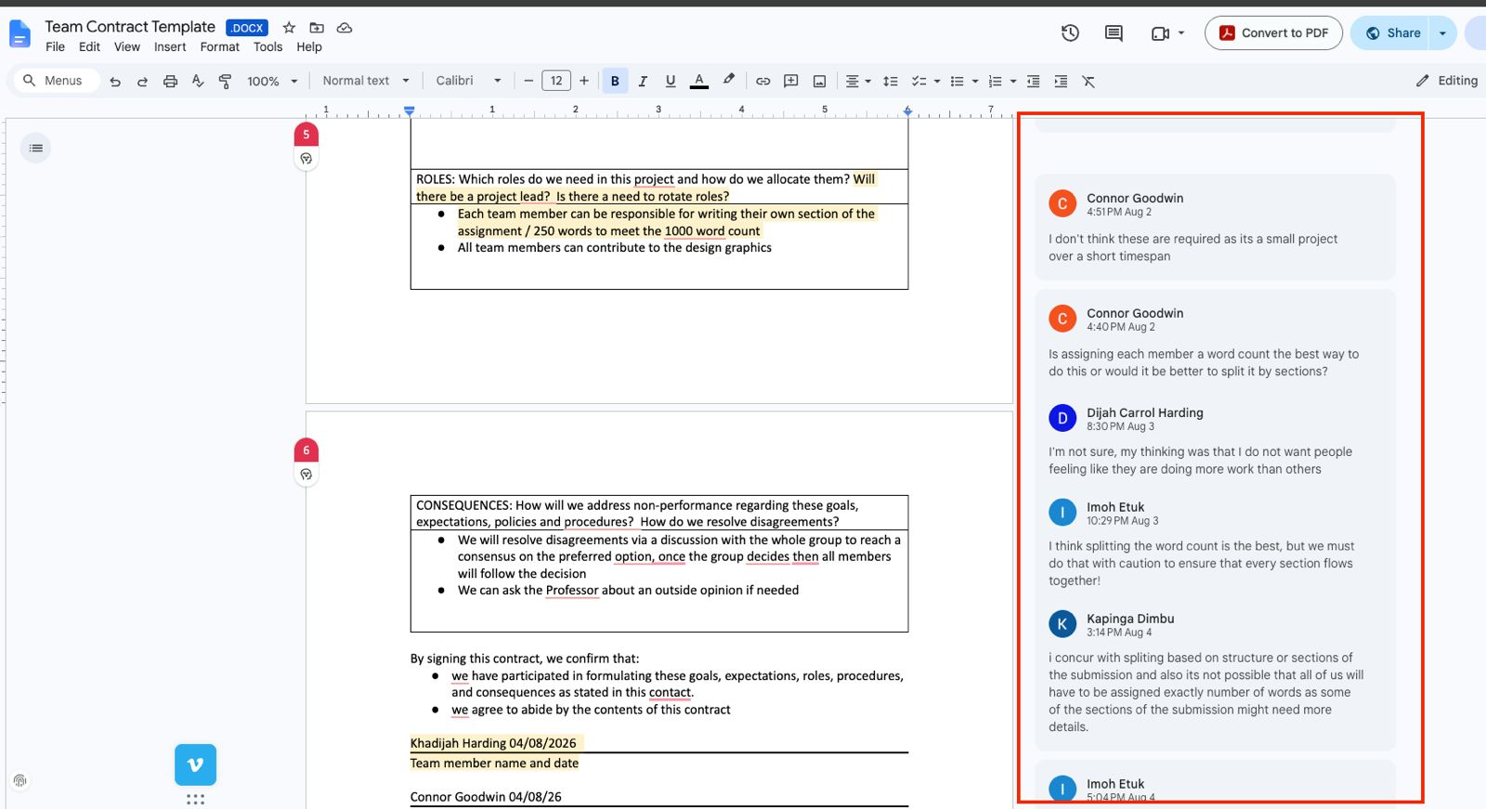
Figure B2. Group discussion on task allocation, word-count division and coordination.

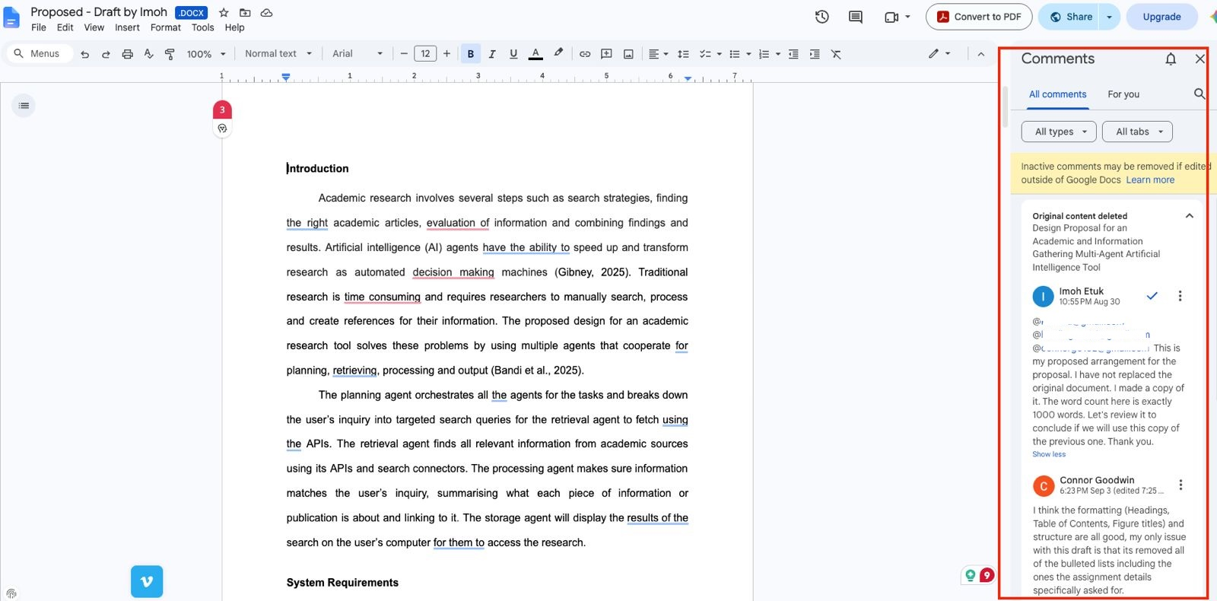
Figure B3. My proposed design draft and comments exchanged with Group C members.
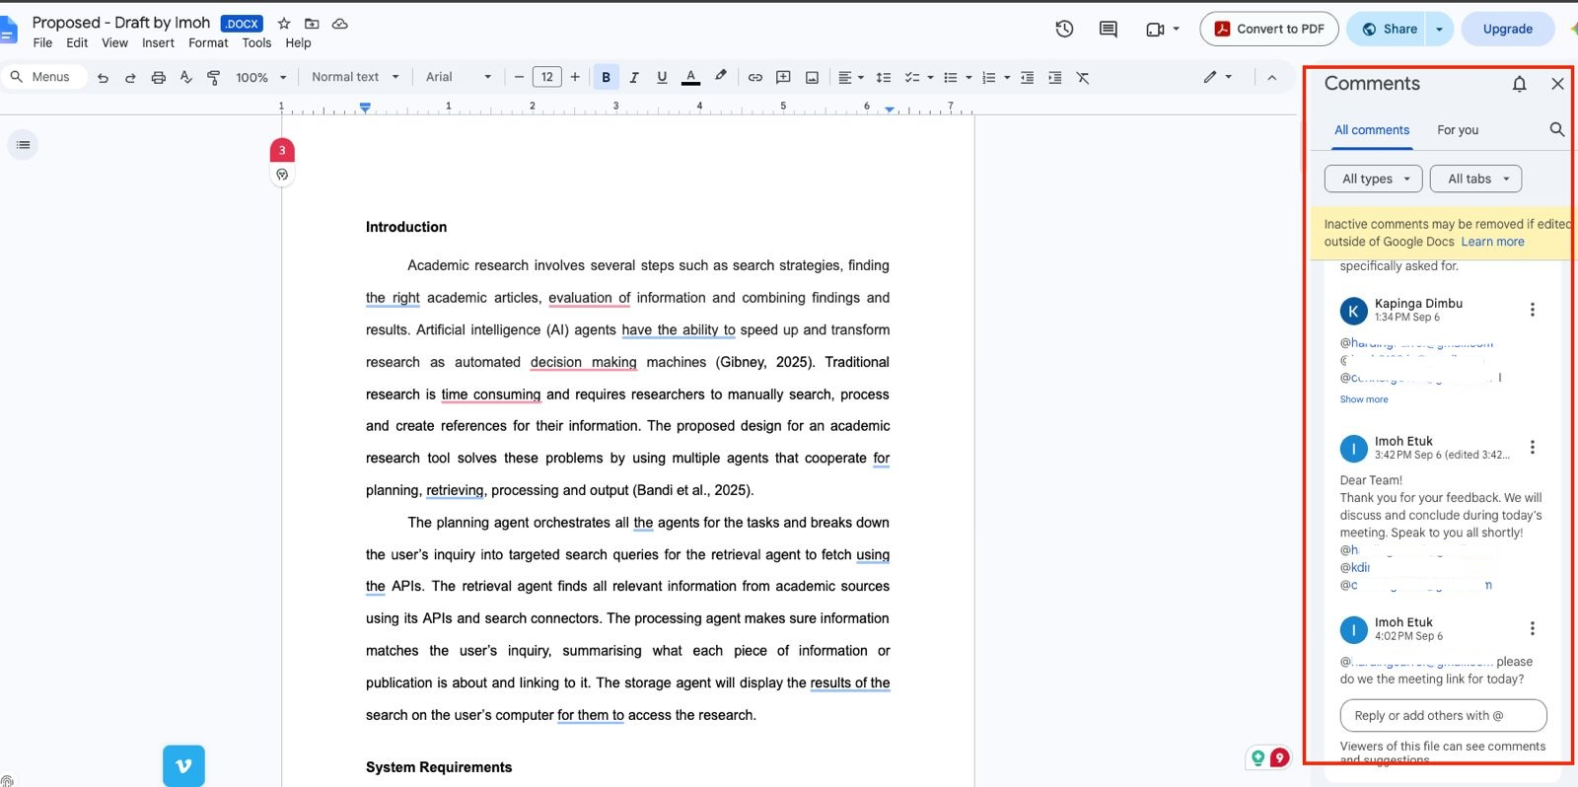
Figure B4. Follow-up discussion and response to peer feedback on the proposed design.

Appendix C – Unit 11 Testing and Execution Evidence
The screenshots below provide direct evidence of the final automated test run and the reproducible offline execution of the Unit 11 Academic Research Agent.
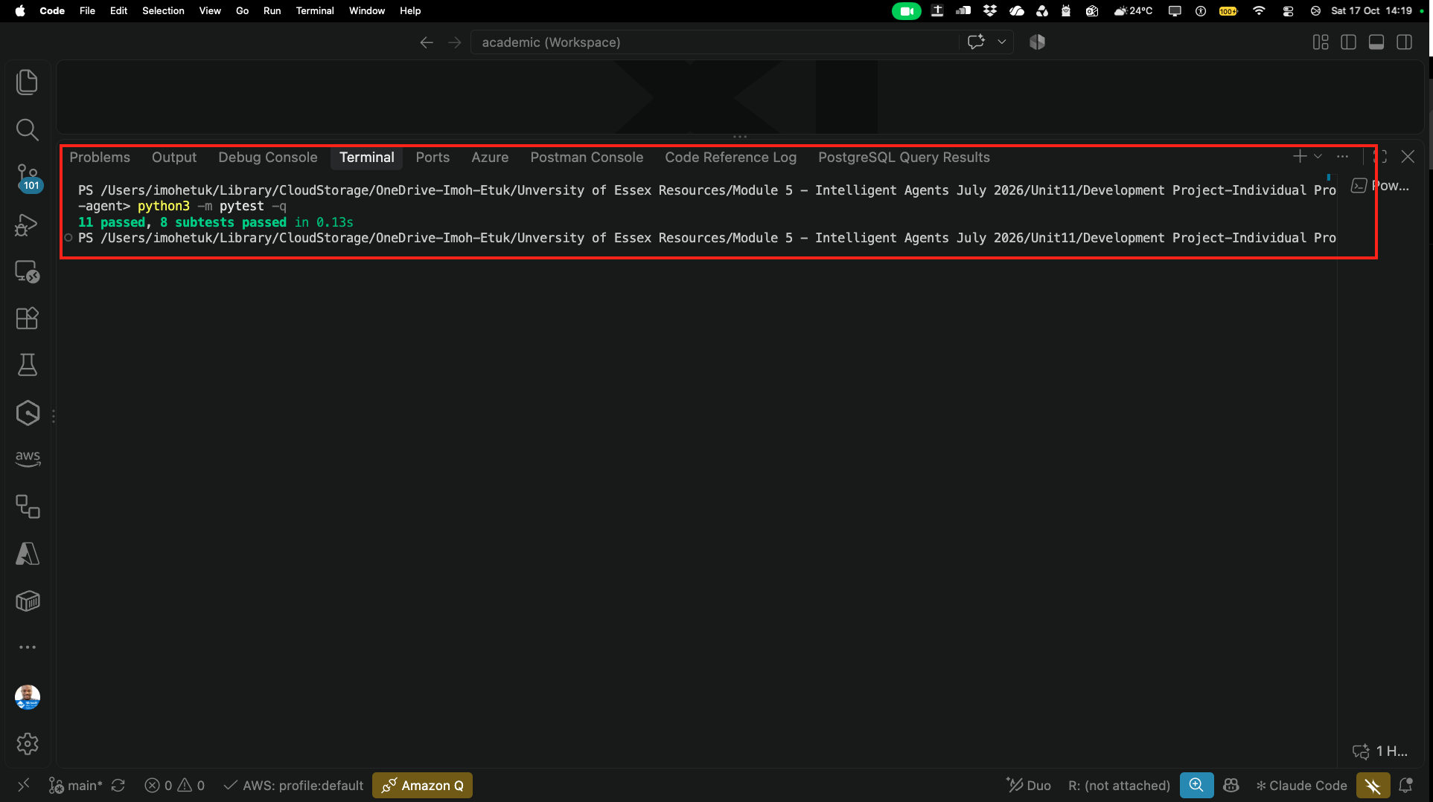
Figure C1. Final automated test run showing 11 tests passed and eight subtests passed.

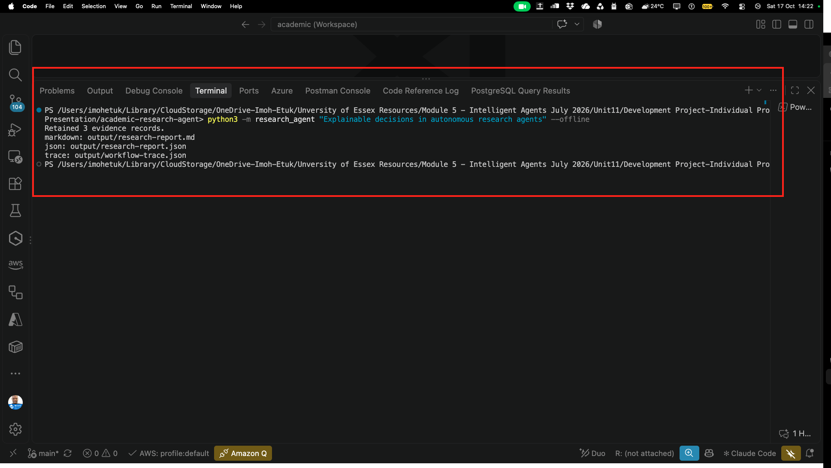
Figure C2. Offline Academic Research Agent execution retaining three evidence records and generating research-report.md, research-report.json and workflow-trace.json.

